Dataset: https://www.kaggle.com/datasets/codingyodha/largest-alzheimer-eeg-dataset
Repo: https://github.com/Pakkuu/CS4485-eeg-alzheimers-detection

Member | Done | Planned | Roadblocks
Venkatasai Gudisa | Chose a healthy control subject and an Alzheimer’s control subject to plot 10 seconds of EEG from P4 for both:  Selected HC subject: AD-Auditory_10  Selected AD subject: AD-Auditory_17 | Plot the EEG
Ajay Alluri | reported  - Total number of subjects  - Number of Healthy Controls (HC)  - Number of Alzheimer’s Disease (AD) subjects  - Number of EEG channels  - Sampling rate (Hz)  - Recording duration (seconds or minutes)
Ethan Varghese | reported  - Shape of the data matrix (Channels × Time samples). Each channel corresponds to electrical activity recorded from a specific scalp location  - Fixed python dependency and pathing issue for kaggle dataset | Preprocess EEG data
Aashay Vishwakarma | - Extracted 10 seconds of data, created time_vector, hc_signal, ad_signal, verify signals for those 3 fields are same length  - 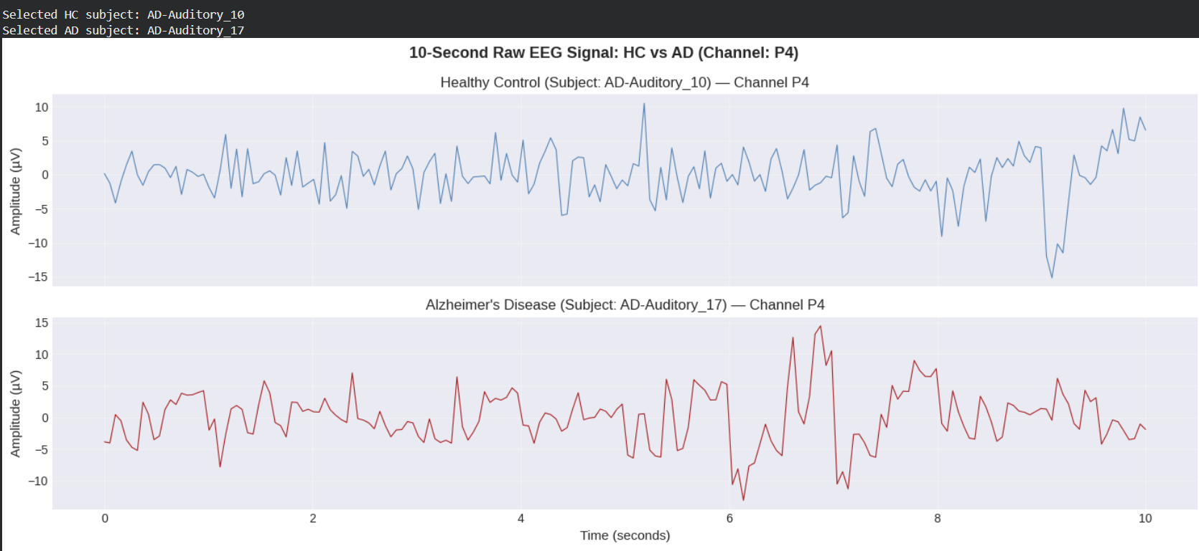 | Plot and analyze 10 seconds of EEG Signal
Venkat Sai Eshwar Varma Sagi | - Took time_vector, hc_signal, ad_signal, created plot A and B, analyzed visual differences.  -  | Plot and analyze 10 seconds of EEG Signal
Ram Gudur | - Continued research on brain wave results of Alzheimer’s patients  - Assisted in choosing both a control subject and a subject with Alzheimer’s for EEG data plotting | Plotting the control subject data against the Alzheimer’s subject data

